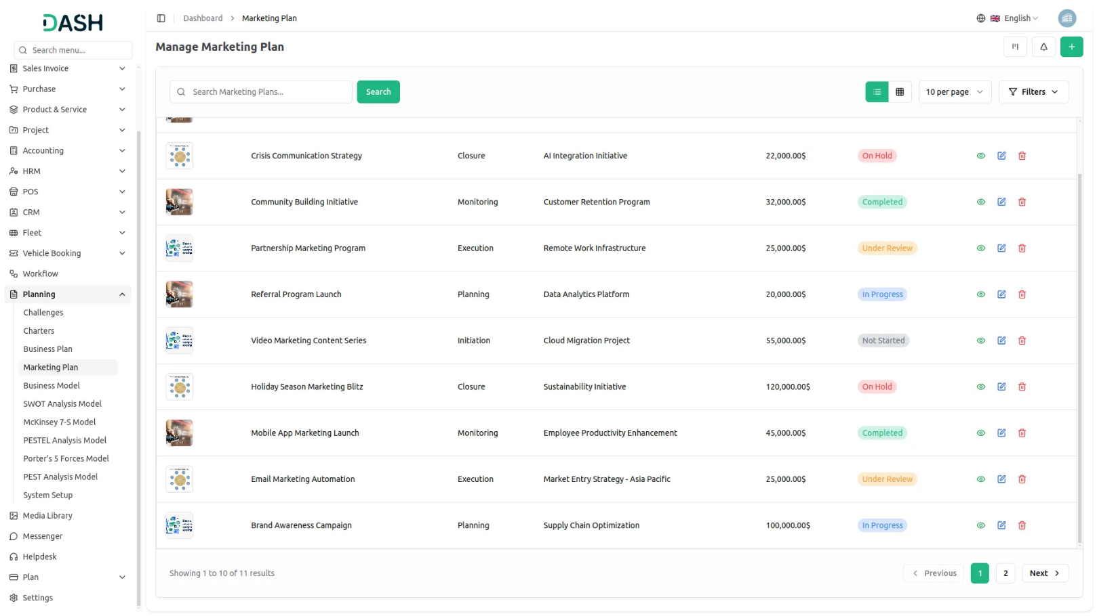

Our Marketing Plan Add-On allows users to create comprehensive marketing strategies within a unified platform. It supports multiple views like grid and kanban, offers printing capabilities, and enables users to add reviews. While creating a plan, users can input key details such as business summary, target market, marketing channels, budget, and team involvement, empowering businesses to plan, visualize, and execute marketing efforts more effectively.
Dependency Notice: This Add-On depends on the Planning Add-On, so you must purchase and activate it first to access the Marketing Plan features.
Enhanced Collaboration and Alignment
Successful marketing requires collaboration and alignment across cross-functional teams. Integrating marketing plan functionality with project management and communication tools enables teams to coordinate tasks, share resources, and communicate effectively throughout the campaign lifecycle. By centralizing communication and workflow management, this approach fosters greater alignment between marketing, sales, and other departments ensuring everyone is working towards common goals and objectives.
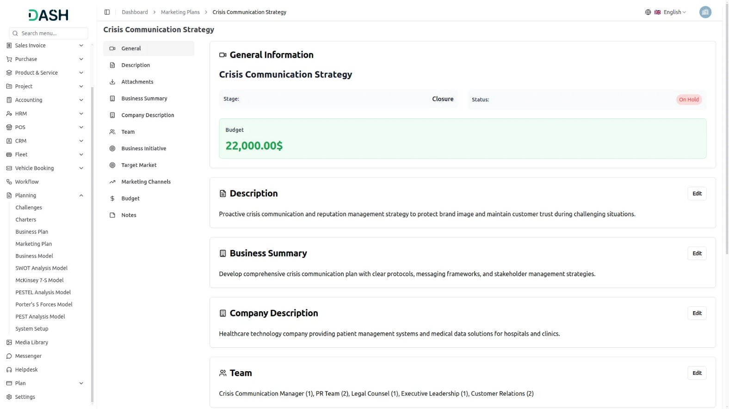
Marketing Strategy Intake Overview
By creating a marketing plan, you agree to provide key business details including your company description, team roles, business initiatives, target market, marketing channels, and budget. Additional information such as plan notes and a thumbnail may also be requested to complete your submission. This data enables us to build a structured, goal-oriented marketing roadmap tailored to your business. All information provided should be accurate and up-to-date to ensure effective planning. Submission confirms your consent to use this data for marketing strategy development and execution.

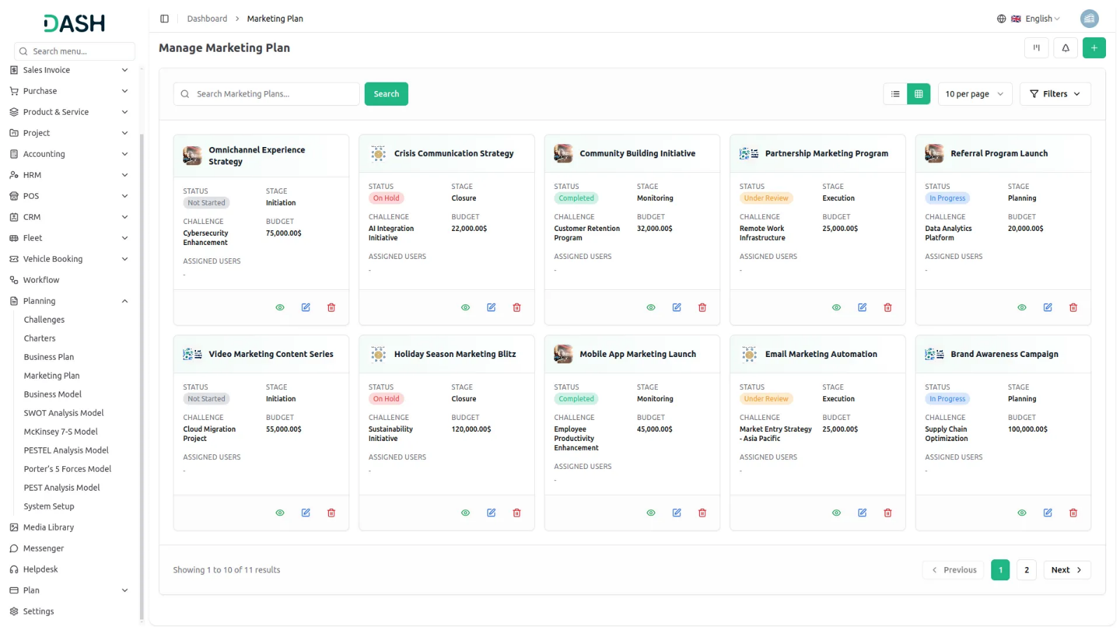
Stage-Based Kanban View for Marketing Plans
Easily manage your marketing plans with a clear, stage-based Kanban view. Marketing Plans are visually organized into columns based on their current stage, allowing users to quickly see how many marketing plans exist under each stage. This layout offers a streamlined overview of your entire marketing workflow, making it simple to track progress, identify bottlenecks, and maintain momentum across all campaigns.

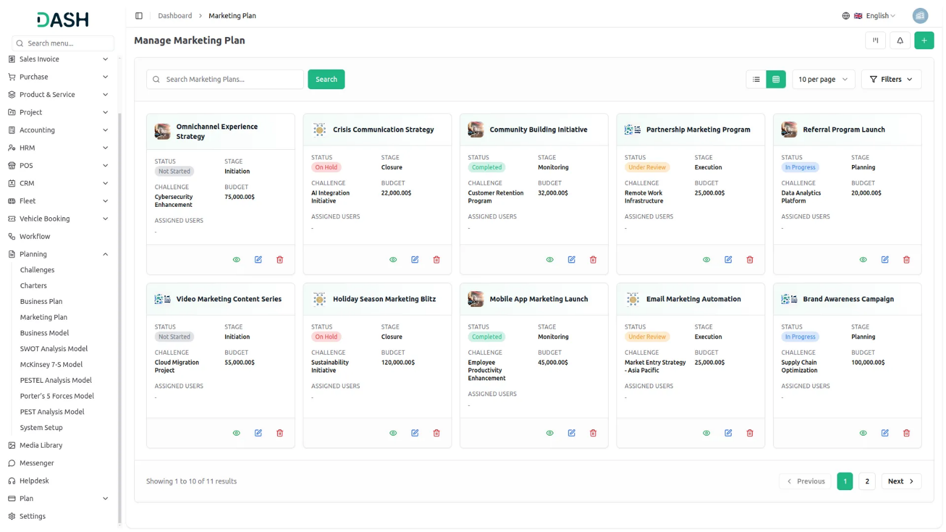
Challenge-Based Tree View for Marketing Plans
Visualize your marketing plans with clarity using our structured tree view. Start by selecting a specific challenge from the dropdown menu, and instantly see all related marketing plans organized beneath it. This hierarchical layout allows users to explore how each plan connects to a broader business challenge, making it easier to manage, navigate, and align strategies with organizational goals. It's a focused, intuitive way to oversee your marketing efforts from challenge to execution.

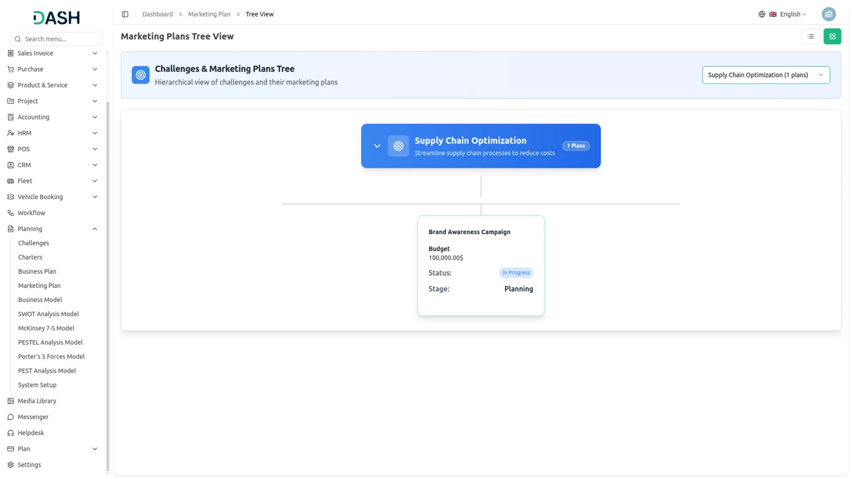

Introduction
The Marketing Plan Add-On is designed to help users build, manage, and execute comprehensive marketing strategies directly within the platform. This add-on allows users to structure their marketing goals, define their target audiences, allocate resources, track performance, and align their marketing efforts with overall business objectives. With a clean interface and detailed input fields, it ensures that every aspect of a marketing plan from campaign objectives to channel strategies is clearly documented and accessible. This documentation provides a step-by-step guide to help you understand how to access the Marketing Plan Add-On, create new plans, manage existing ones, and make the most out of its features for effective marketing execution.

Note: This Add-On is dependent on the Planning Add-On, so you need to purchase it first.

How to Use the Marketing Plan Add-On?
Managing the Marketing Plan
- The default list view displays all Marketing Plans in a table format with columns showing Thumbnail Image, Creativity Name, Status, Stage, Challenge, total number of assigned Users, Roles, Rating, total number of Comments, End Time, and Actions. Use the search function to find specific plans quickly.
- In the Actions column, you can click “View” to see all details, “Edit” to modify any information in the plan, or “Delete” to remove the plan permanently.
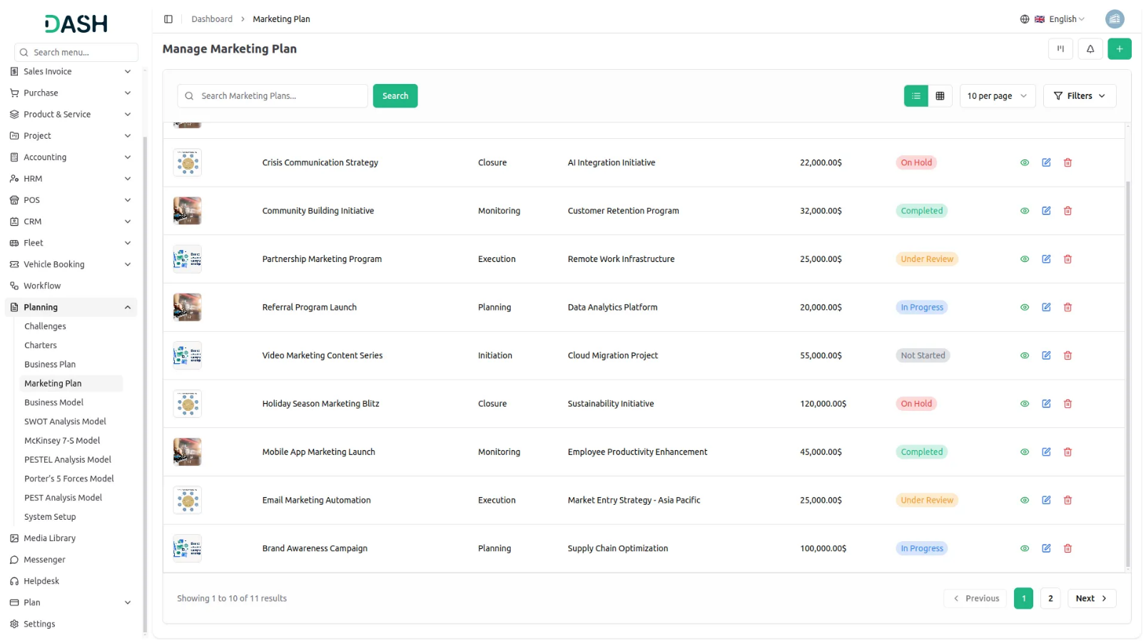
Creating a Marketing Plan
- To create a new Marketing Plan, click the “Create” button at the top of the page. Enter the name of your marketing plan and select a challenge. Note that you can only create a Marketing Plan if the current date is before the challenge end date.
- Upload a thumbnail image to represent your marketing plan visually, then upload a video file if needed for additional context or presentations. Select the status from the system setup options and choose the appropriate stage from the available system setup stages.
- Next, assign users who will be involved in this marketing plan and select their roles. Add a detailed description explaining the purpose and scope of your marketing plan.
- Upload any supporting attachments that might be helpful for the plan. Fill in the business summary section with key business information, then add your company description. Enter details about your team members and their responsibilities in the Team field.
- Define your business initiative and identify your target market in the respective fields. Select your marketing channels from the available options and enter your budget information. Add any additional notes in the Notes section and click “Create” to save your Marketing Plan.
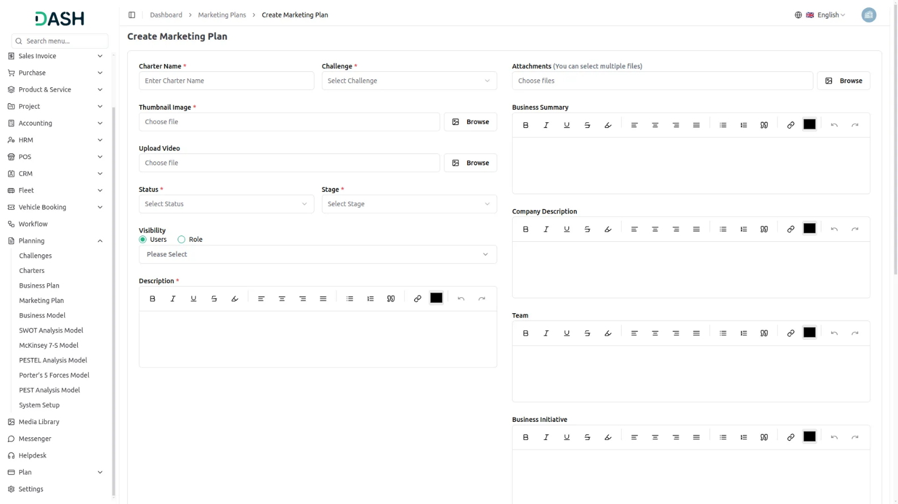
View Marketing Plan Details
- When you click the “View” button in the Actions column, you will see a detailed page with expandable sections. The General section is highlighted in green and contains basic information like name, associated challenge, thumbnail image, uploaded video, current status, stage, assigned users, and their roles.
- Click on Business Summary to expand and view the complete business summary of the marketing plan. You can use the “Edit” button below this section to add additional business summary content. The Company Description section shows company information with an “Edit” button for additional company details.
- The Attachments section shows all uploaded supporting files, with an “Edit” button to upload more attachments. Expand Team to review team member information and use the “Edit” button to add more team details.
- The Business Initiative section displays business initiatives and goals with an “Edit” button to add more initiative information. Target Market shows target market analysis with an “Edit” button to include more market data.
- Expand Marketing Channels to view selected marketing channels and strategies with an “Edit” button to include additional channel information. The Budget section displays budget information with an “Edit” button to add more budget details.
- The Notes section contains any additional notes added during creation, with an “Edit” button to include more notes. In the Comment section, you can add new comments related to the marketing plan and attach files to your comments using the “Edit” button.
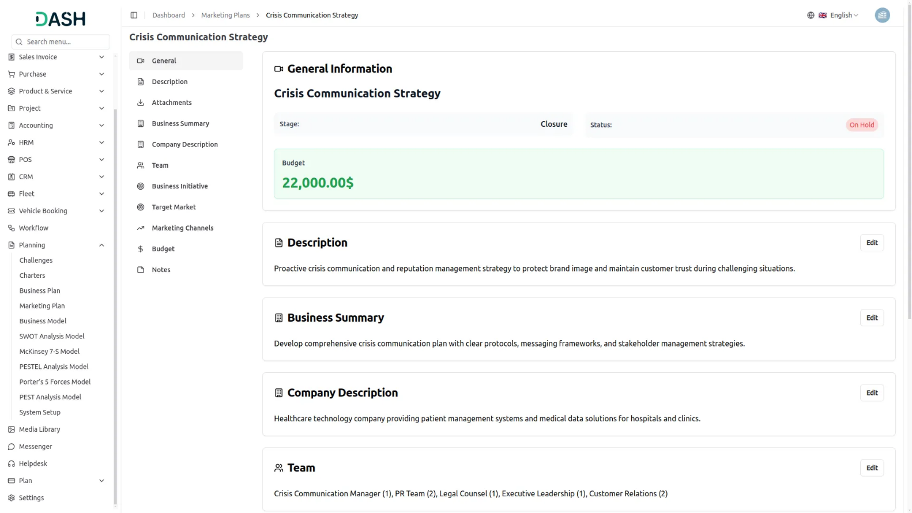

Kanban View
- Click the “Kanban” button to display your Marketing Plans in a board layout with columns representing different stages. Each plan appears as a card showing the thumbnail image, creativity name, status, challenge, and total number of assigned users.
- Each card also includes action buttons for View, Edit, and Delete. You can drag and drop cards between columns to update their stage status easily. This view is perfect for tracking the progress of multiple marketing plans and managing workflow stages visually.
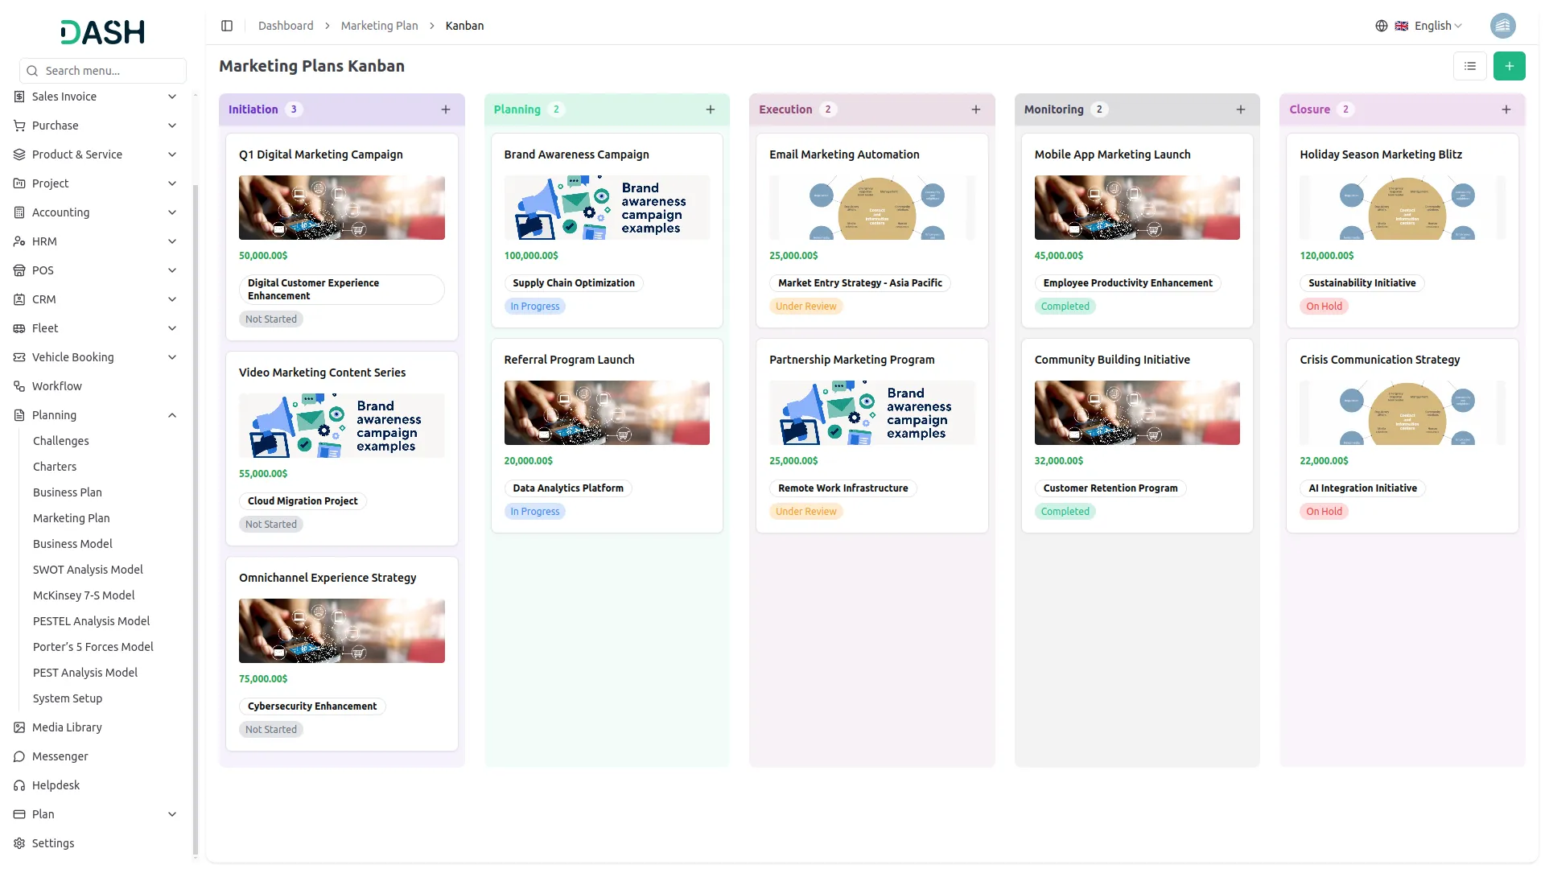

Grid View
- Click the Grid View button to see all Marketing Plans displayed in a card-based layout. Each plan appears as an individual card showing the thumbnail image, creativity name, status, stage, challenge, total number of assigned users, roles, rating, total number of comments, total number of attachments, and end time.
- Each card also includes action buttons for View, Edit, and Delete. This view provides a visual overview of all your marketing plans in an organized grid format, making it easy to browse and compare different plans at a glance.

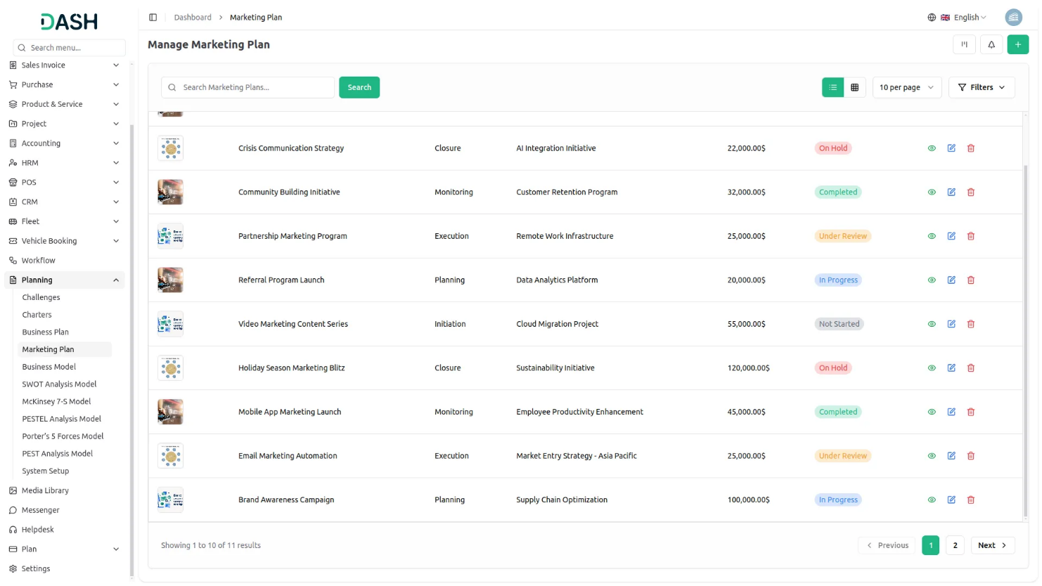

Tree View
- To switch to Tree View, click the “Tree View” button at the top of the page. This view presents a hierarchical structure that displays challenges and their associated Marketing Plans in an expandable tree format, showing the parent-child relationships clearly.
- The Tree View includes expand/collapse functionality, indicated by the arrow icon next to each challenge name. Clicking the arrow allows you to expand the challenge to reveal its associated models or collapse it to show only the challenge title, making navigation more organized and focused.
- In the Tree view, each challenge appears as a blue header bar with the number of plans indicated. When expanded, it displays the associated models beneath it in card format, showing key details including the model name, status, stage displayed as stars.

